Manhattan phase id: 0: Nothing?

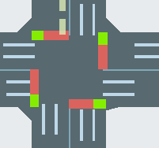

Manhattan phase id: 1. **W-E, E-W**

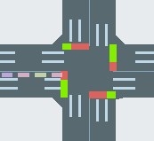

Manhattan phase id: 2. **N-S, S-N**

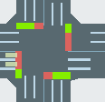

Manhattan phase id: 3: **W-N, E-S**

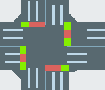

Manhattan phase id: 4: **N-E, S-W**

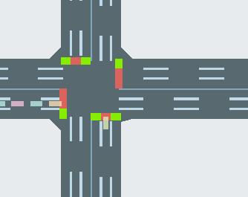

Manhattan phase id: 5: **W-NSE**

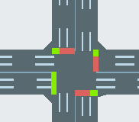

Manhattan phase id: 6: **E-NSW**

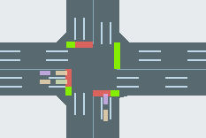

Manhattan phase id: 7: **S-WEN**

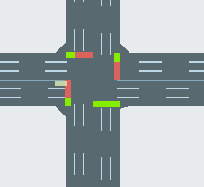

Manhattan phase id: 8: **S-WES**

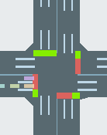

Ordering roads per intersection:

